**Batch: B1 Roll No.: 16010121045**

**Experiment No. 3**

|  |
| --- |
| **Title:**  Perform Network Scanning using NMAP |

**Objective:**

Perform Network Scanning using NMAP

|  |  |
| --- | --- |
| **CO** | **Outcome** |
| **CO1** | Understand penetration testing with scope of its ethical implications, documentation and reporting |

**______________________________________________________________________**

**Books/ Journals/ Websites referred:**

* <https://nmap.org/>
* <https://nmap.org/book/man.html>

**Introduction:**

Network scanning is a critical aspect of cybersecurity, allowing professionals to assess the security posture of a network by identifying open ports, services running on those ports, and potential vulnerabilities within those services. Nmap (Network Mapper) stands out as one of the most widely used and powerful network scanning tools available today. It enables security analysts, administrators, and ethical hackers to gather comprehensive information about network hosts, services, and their configurations.

Nmap's versatility allows for the detection of open ports, services running on those ports, and potential vulnerabilities associated with those services. The study delves into specific services commonly found in networks, including SSH, SMB, FTP, VNC, and MySQL, highlighting how Nmap can be leveraged to assess their security posture. By utilizing Nmap's extensive range of scanning techniques and scripts, organizations can proactively identify and mitigate security risks, thus enhancing their overall cybersecurity posture.

**SSH (Secure Shell):**

SSH is a cryptographic network protocol used for secure remote access to systems. Nmap can detect SSH services running on a network by scanning for open port 22, the default port for SSH. Additionally, Nmap can identify the version of SSH running, aiding in determining potential vulnerabilities associated with specific versions.

**SMB (Server Message Block):**

SMB is a network protocol used for providing shared access to files, printers, and other resources between nodes on a network. Nmap can identify SMB services by scanning for open ports 445 (SMB over TCP) and 139 (NetBIOS over TCP), allowing for the detection of potential vulnerabilities such as unauthenticated access, misconfigured shares, or outdated software versions.

**FTP (File Transfer Protocol):**

FTP is a standard network protocol used for transferring files between a client and a server on a computer network. Nmap can detect FTP services by scanning for open port 21, the default port for FTP. Through banner grabbing and version detection, Nmap can identify FTP server software and potential vulnerabilities such as weak authentication mechanisms or outdated software versions.

**VNC (Virtual Network Computing):**

VNC is a graphical desktop sharing system that allows users to remotely control another computer. Nmap can detect VNC services by scanning for open ports such as 5900, the default port used by VNC servers. By identifying VNC services and their associated versions, Nmap helps in assessing the security posture of remote desktop access and detecting potential vulnerabilities.

**MySQL:**

MySQL is a popular open-source relational database management system. Nmap can identify MySQL services by scanning for open port 3306, the default port for MySQL. Furthermore, Nmap can enumerate MySQL server information and versions, aiding in the identification of potential vulnerabilities such as weak authentication mechanisms, misconfigurations, or outdated software versions.

**Implementation details:**

The following screenshots depict the exploited vulnerabilities identified through lab experiments using Nmap:

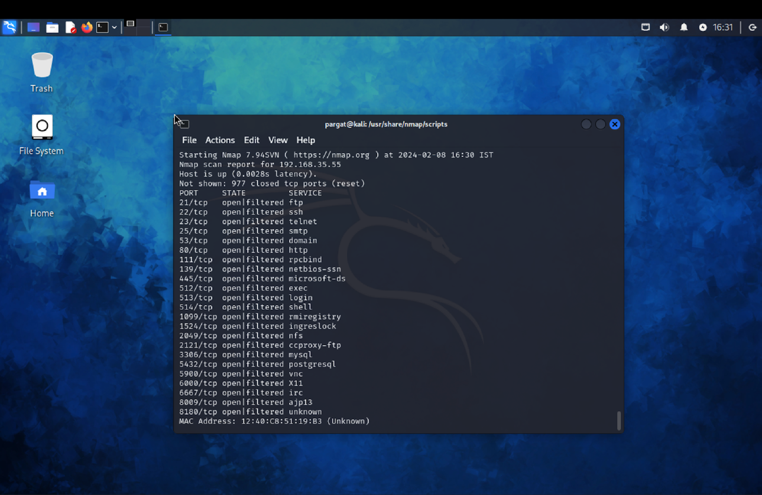

SSH

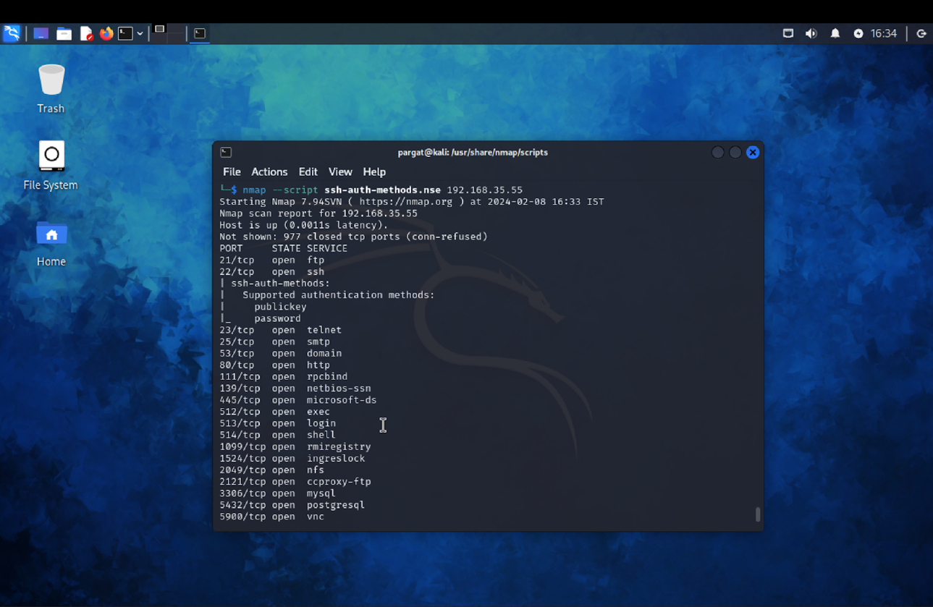

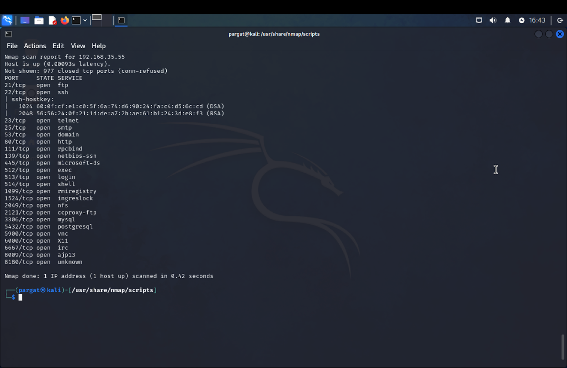

SMB

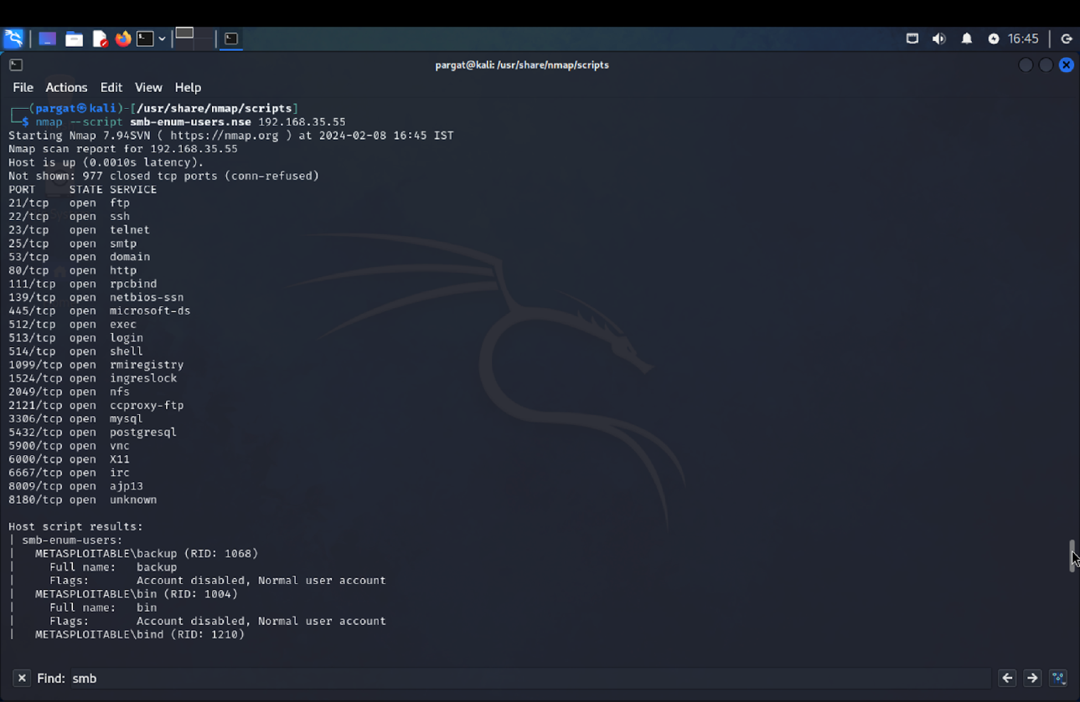

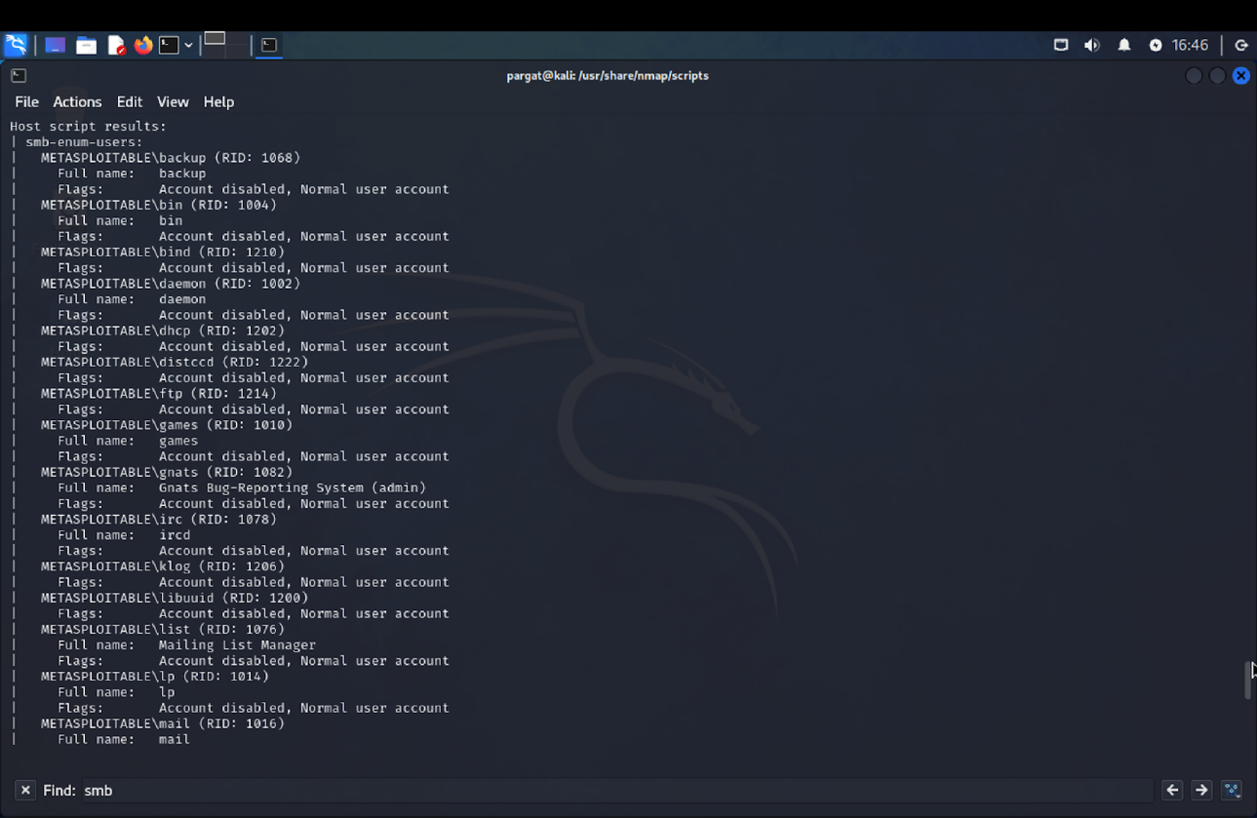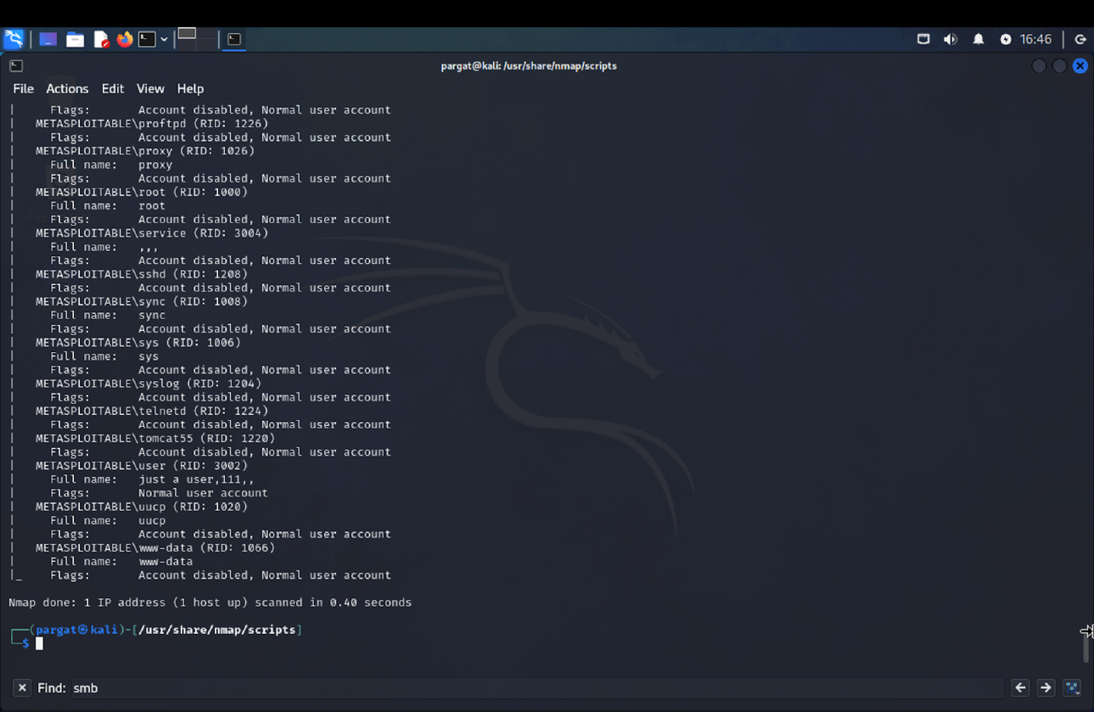

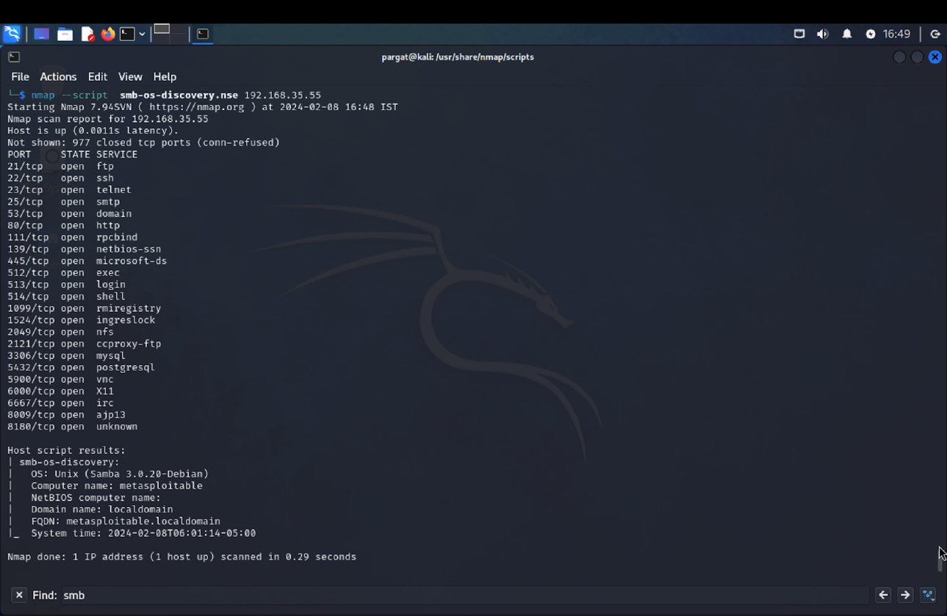

FTP

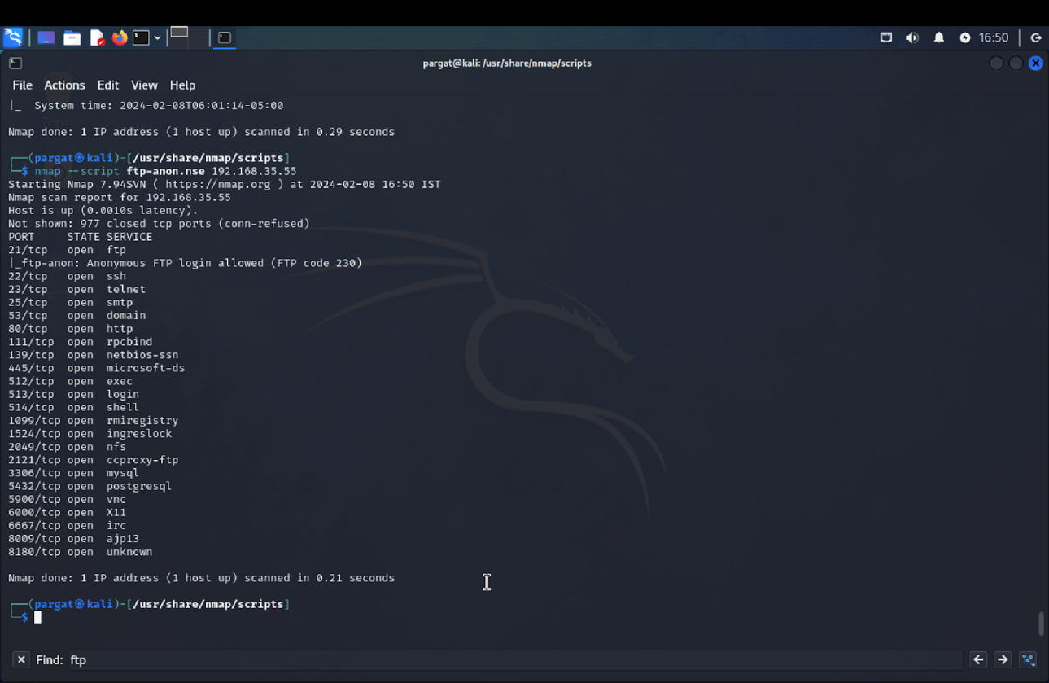

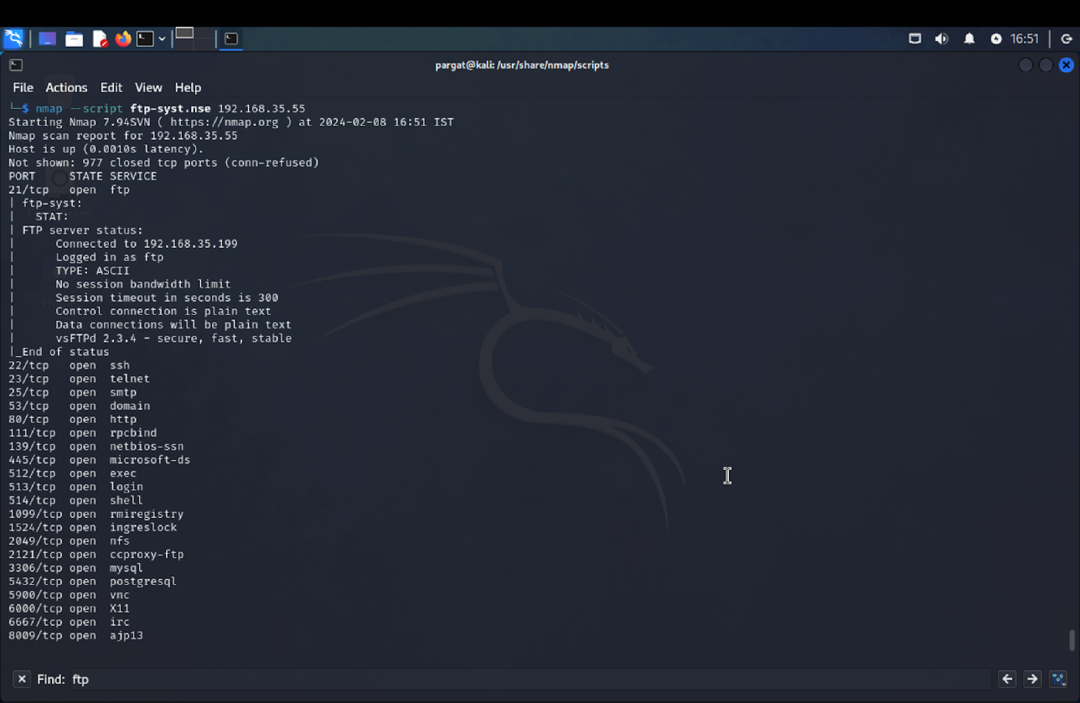

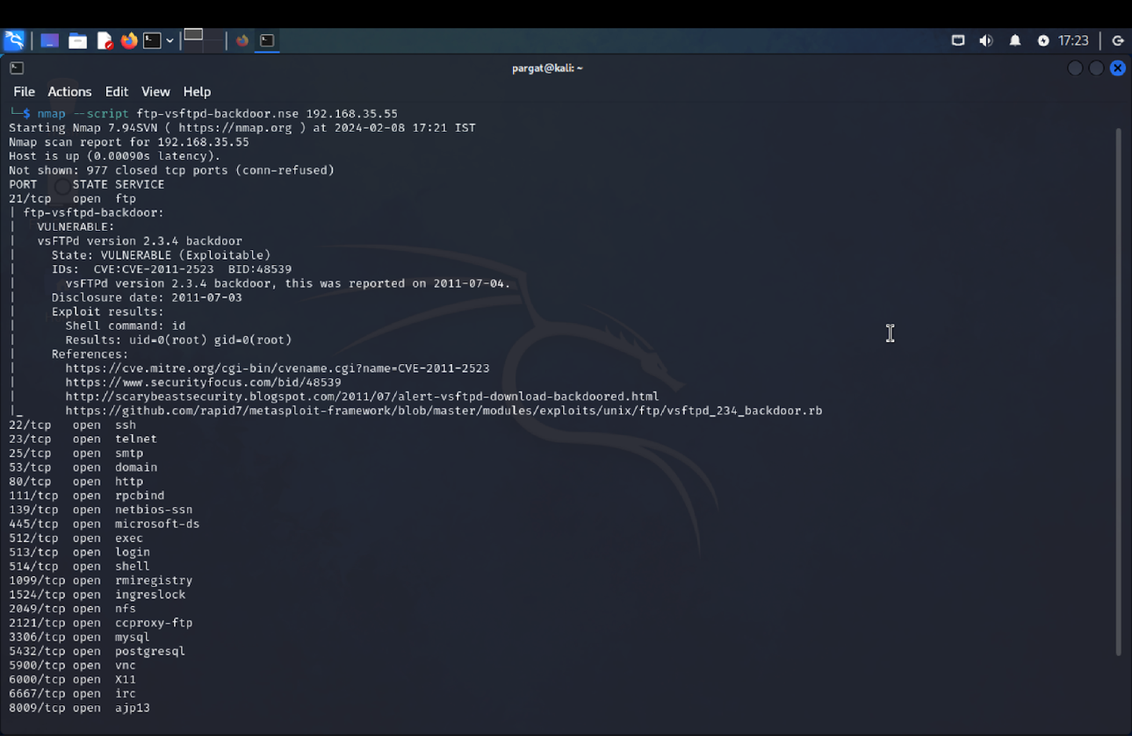

VNC

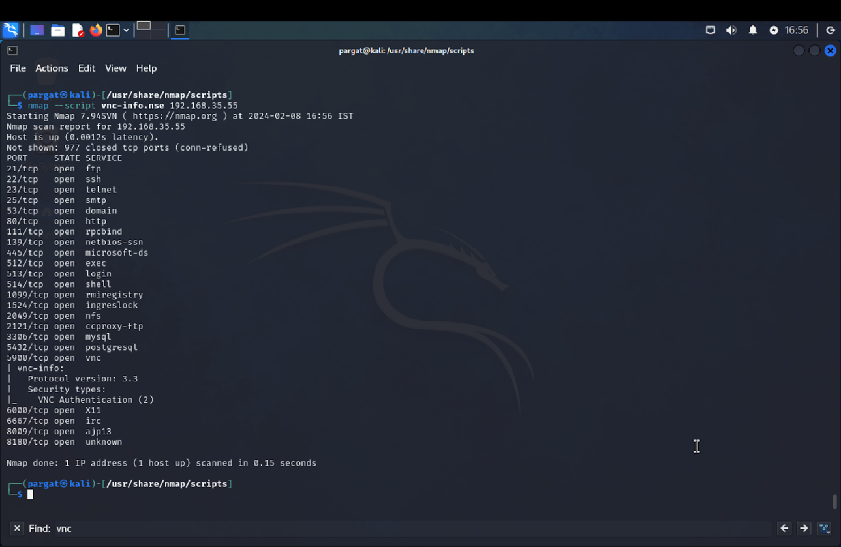

MYSQL

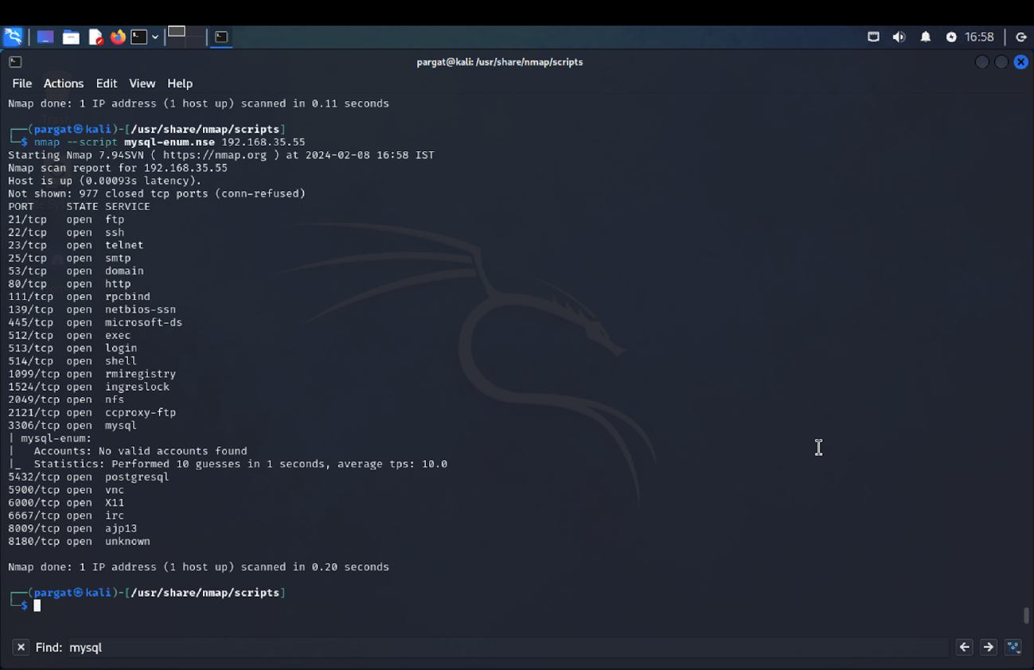

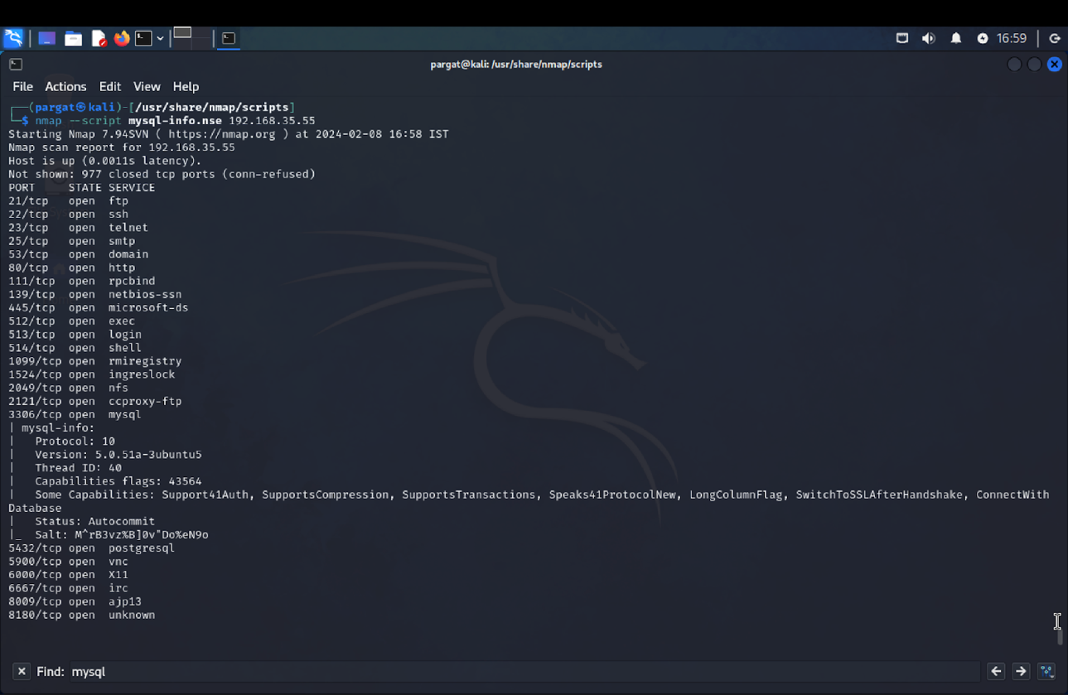

**Conclusion:**

Through NMAP's extensive scanning capabilities, we obtained crucial insights into the targeted network's structure and vulnerabilities. The scan revealed active hosts, open ports, and services running on those ports, offering valuable information for enhancing network security. NMAP's diverse scanning techniques enabled comprehensive analysis, empowering network administrators to prioritize security measures effectively.